Technical Design Document for Chat Analysis System
Vesion1 Approved

Prepared by Group2

Issue 1
TABLE OF CONTENTS
0 Preface 1
0.1 Purpose of this document 1
0.2 Use of this document 1
0.3 Overview 2
0.4 Basis of this Document 2
0.5 Specific Design Considerations 3
1 Introduction 5
1.1 Purpose 5
1.2 Scope 5
1.3 Definitions, Acronyms and Abbreviations 5
1.4 References 6

2 System Overview 7
2.1 System Characteristics 7
2.2 System Architecture 7
2.3 Infrastructure Services 9
3 System Context 10
4 System Design 11
4.1 Design Method and Standards 11
4.2 Documentation Standards 12
4.3 Naming conventions 13
4.4 Programming Standards 13
4.5 Software development tools 13
4.6 Outstanding Issues 14
4.7 Decomposition Description 14
5 Component Description 15
5.1 Component Identifier 16
6 Software Requirements Traceability Matrix 19
Document Control 20
Document Signoff 20
Document Change Record 20

0 Preface
  - Purpose of this document
This Technical Design Document is a document for use of the Chat Analysis system. It provides guidance that will assist the technical staff in producing a project-specific Technical Design Document. It is also useful background reading for the developers and the project manager of the Chat Analysis system.
0.2 Use of this document
This document is addressed to the technical staff who will use it in the design of the intended system basing on the details the document provides.
This document has been prepared using MS Word 2016.
0.3 OVERVIEW
Section 0 is the Preface and it includes the purpose of this document, its use, and overview, the basis of the document, reference documents and the specific design considerations.

Section 1 is the introduction and it includes a description of the project, its purpose, definitions, acronyms and abbreviations, applicable and reference documents.

Section 2 provides a system overview that describes in detail the system characteristics, system architecture and the infrastructure services.
Section 3 is system context and it defines all the external interfaces of the system basing on a system block diagram or context diagram to illustrate the relationship between this system and other systems.

Section 4 is system design and it describes in detail the design method and standards used, documentation standards, naming conventions, programming standards, software development tools used. It also states clearly if there are any outstanding issues and also includes illustrations for decomposition description.

Section 5 is the component description and it describes in detail the component identifier, the type of the component, its purpose, function and subordinates (includes a list of modules that are ‘called by’ this component). It also clearly states any dependencies which include the constraints placed upon its use by other components.
It also describes the interfaces of the component; the resources a component requires, explicit references where a component description uses or implies material from another document are also stated. The processing of the component is also defined and the data internal to a component is also defined.

0.4 Basis of this Document
This document is based on the data availed to us by the NSSF staff and knowledge of how exactly the system will work. The template also helped with what we are supposed to include in this document.

0.6 Specific Design Considerations

Assumptions and dependencies

All users are assumed to be computer literate and have basic knowledge about visualization that is; histograms, scatter plots, bar graphs and pie charts.
The system is developed in R using R Studio therefore, the user must have both installed on their computer along with all the required packages for R and data analysis in order for the system to run efficiently.

It requires the latest R version 3.4.0 or higher and this applies to both Windows and Linux users.
The system is assumed to be accessed only by authorized personnel who are; NSSF Uganda staff, Data Analysts and the System Administrator.
The system should be able to accommodate any changes in functionality as the system administrator will be making upgrades where and when necessary

General constraints
The system is limited by a number of factors as highlighted below;

Hardware Constraints:
The system will be able to support less than 20 users at a time with repository of 10-60GB,
having a minimum configuration of 1GB – 2GB RAM, 1-2 Cores (1.86 GHz), 30-180 GB SATA (hard disk) and configuration for better performance 2GB – 4GB RAM.

Time Constraint:
The system will be delivered by 16th August 2018.

Technology Constraints:
The system will require use of web server technologies such as R Shiny Server, Statistical Analysis, Visualization tools and it will not have a database.

Cost Constraint:
The design phase may require maintenance of the hardware needed for implementation of the system. This may be costly.

Programming Standards:
The system will be maintained by the development team and incase of any query about the system, it should be submitted to that team.

Communication Protocols:
The system will use Two-tier architecture where the client will directly communicate with the server.

Language Requirement:
The system will strictly use English as the standard language.

Goals and guidelines

The goal of the system is to enable its users interact with it easily using the interfaces provided and it should also be working, looking and feeling like an existing product.
Emphasis has been put on the speed since there is no need of first establishing a connection between the client and server. This ought to make the system function faster.

Development methods

Unified Modelling Language is the design method used here. UML diagrams describe the boundary, structure and the behavior of the system and the objects with in it. UML is not a programming language but these are tools that can be used to generate code in various languages using UML diagrams. UML has a direct relation with object-oriented analysis and design.
The purpose of UML diagrams is to visually represent a system along with its main actors, roles, actions, artifacts or classes in order to better understand, alter, maintain, or document the information about the system.
A data flow diagram is a graphical representation of the “flow” of the data through an information system, modeling its process aspects.
A DFD is often used as a preliminary step to create an overview of the system without going into great detail, which can be elaborated later.

Introduction
This design document is a reference document which can be used to design and develop a system that analyses the data from the chats provided, to enable the users of the system to understand the chat data better.
The system will be able to run on any windows versions above Windows 7, Linux or Mac OS X. It will use the R programming language of version 3.4.0 or higher and RStudio, packages like the shiny package will also be used. All these have to be installed on your computer.
The system will be accessed by the developers using the same password but a different username for each to make updates if necessary (They can also access the visualized data using the password for the NSSF staff). It will also be accessed by the NSSF staff using the same password (different from the one developers use) but different usernames to access the visualized and analysed data.

Purpose
This document provides the brief overview of the Chat Analysis system and its architecture. It also provides a step-by-step guidance to how the users are to use the system to help the customers with how NSSF Uganda works.
The objective of this document is to help the developers to build a system that helps the users understand the data they are working with. It will be used by the developers who will use it to develop the intended system.
This document is to be read by the design team to implement the intended system.

Scope
Implementation of this system will produce well analysed data that is more specific about the customers.
The proposed system will enable the staff of NSSF Uganda to attend to customers’ queries more efficiently. This will be more specific and therefore faster. The system may not be able to help customers with real-time queries.
The benefits of the document include; Implementation of the system will categorize similar queries from the customers thereby increasing efficiency.
NSSF staff will be able to know when their customers need more attention and this will improve on the service quality.
The objective of this document is to help the developers to build a system that helps the users understand the data they are working with.

The goals of the document are;
- To design a system that examines what the customers think and enable the NSSF staff use this information to improve on the organization’s products and services.
- To design a system that examines chat patterns and enables data analysts understand the needs of the customers.

The system requires all NSSF staff to login using the same password but each with a different username and likewise all data analysts to login using the same password but each with a different username. This may be risky if an unauthorized user gets any of the passwords.

Definitions, Acronyms and Abbreviations
DFD: Data Flow Diagram
UML: Unified Modelling Language
Terms covering the development of software using the Unified Modelling Language (UML) approach – which is recommended if an OOD view of the system is to be developed – should be included for completeness.
The following is a list of definitions for this template based on the UML approach to system design:

Class Diagram | Describes the structure of a system
State chart Diagram | Expresses possible states of a class (or a system)
Activity Diagram | Describes activities and actions taking place in a system
Sequence Diagram | Shows one or several sequences of messages sent among a set of objects
Use-case Diagrams | Illustrates the relationships between use cases

References
Below are the references we used to make the Technical Design document of the Data Analysis Software System:
- System Analysis and Design UML Edition by Denis Wixom and Doth.
- WorldWeb.com.
- DA-MS-TD Technical Design Document template.

System Overview
The NSSF Chat Analysis Project is for analyzing data sets availed to us from the NSSF Organization. The data sets involve chat content between NSSF and its customers from different countries. The data in these chats is collected within the months of May and June of the year 2016. Customers’ views are directed to the Customer Support Department and respective responses are returned to the customers.
NSSF hopes to further their progress to reaching their goals through the results of the analysis provided by this project.

System Characteristics
The NSSF Chat Analysis Project will provide the following services:
- Text Mining: NSSF customers’ views or questions will be gathered using the text mining technique. This will be done by the use of some R packages such as ggplot2, sentiment, wordcloud, corpus among others.
- Sentimental Analysis: This will use the results obtained from text mining to gather the sentiments of the customers and the quality of feedback from the NSSF staff specifically the Customer Support Department.
- Data Visualization: NSSF Chat Analysis Project will have some visuals representing data from the availed datasets. This will be achieved by using some R packages. It will help us to determine the efficiency and effectiveness of the NSSF Organization in Uganda and which means of communication are most reliably used by the NSSF customers and why.

This is represented in the context diagram as shown:
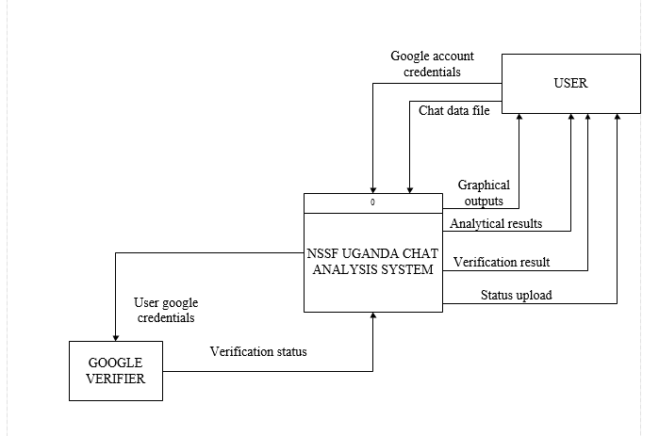

System Architecture

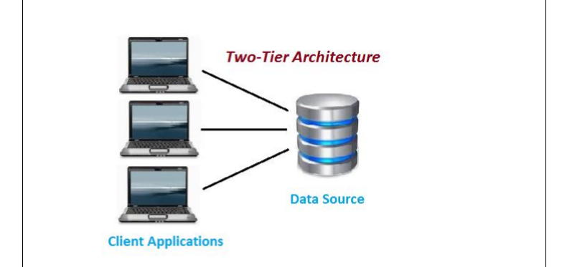

This product will use two-tier architecture also known as the client-server architecture.

On the client side lies the presentation and application layers. In regards to our system, the client side is where the code is written in R Studio and it contains the user interface that will be used to interact with the system.

The server side is where we have the database layer. This is where the data to be analysed is stored.

There is direct communication between the client and the server, that is, there is no need for a third layer.

The architecture was chosen because of the following reasons:

Direct communication: There is no need of a middle layer to connect the client and server systems.

There is no need of a database management system in the product.

Communication is faster since there is no need of first establishing a connection between the client and server.

Infrastructure Services
The organization of services offered by the NSSF Chat Analysis System will be structured as shown below in the Entity Relationship Diagram.
This shows the different entities involved in and out of the NSSF Chat Analysis System.
NSSF offers services to their customers who then send their views back to NSSF Organization.
The Customer Support Team who is part of the NSSF Organization then responds accordingly to customer views.
The marketing staff is responsible for advertising new and existing services to the customers on behalf of NSSF Organization.
The Data Analyst visualizes the data and avails this data and the summarized high quality information to the company executives who use this information for decision making, and draw future plans and expectations of the organization.
Entity Relationship Diagram
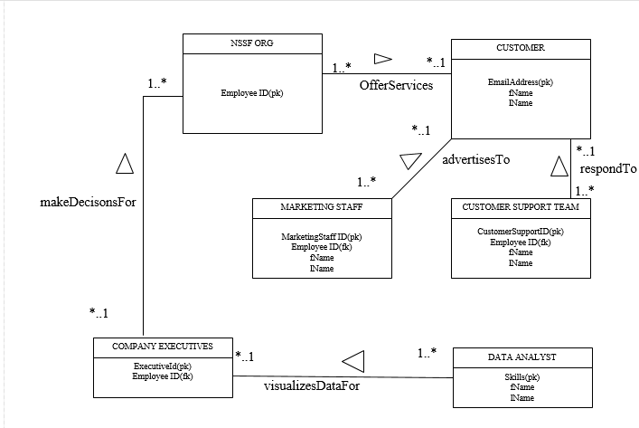

System Context
The Data Flow Diagram shown below is used to break down the system further than in the context diagram already shown above. The DFD starts from customers sending in their views through websites, emails and phone calls from different countries to NSSF Organization. NSSF then sends this data in form of a csv file to the system and it is imported and structured in R.
Text mining is then carried out and the useful information obtained is used to visualize graphs and create word clouds to be used for analysis.
This analysis can be used by the marketing staff to improve on their advertising work.
Data Flow Diagram

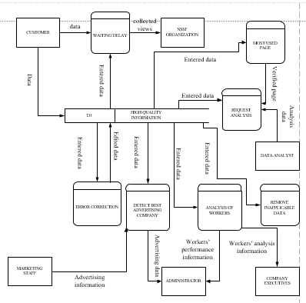

System Design
The design methodology and notation used is UML that is unified modelling language. The approach used is agile in order to accommodate any future changes.

Design Method and Standards
Unified Modelling Language is the design method used here. UML diagrams describe the boundary, structure and the behavior of the system and the objects with in it. UML is not a programming language but these are tools that can be used to generate code in various languages using UML diagrams. UML has a direct relation with object-oriented analysis and design.
The purpose of UML diagrams is to visually represent a system along with its main actors, roles, actions, artifacts or classes in order to better understand, alter, maintain, or document the information about the system.
A data flow diagram is a graphical representation of the “flow” of the data through an information system, modeling its process aspects. A DFD is often used as a preliminary step to create an overview of the system without going into great detail, which can be elaborated later.

Documentation Standards
There are three documentation standards used here that is;
- Documentation production process: these show the process followed for document production.
It is an iterative process involving drafting, checking, and revising the document until the acceptable quality is produced.
- Document standards: these govern the structure and presentation of the documents.
Documents should have a consistent style and appearance, and documents of the same type should have a consistent structure
- Document interchange standards: these ensure that all the electronic copies of the document are compatible.
Examples of interchange standards include; the use of a standard style sheet if a word processor is used or limitations on the use of document macros to avoid possible virus infection.
Interchange standards may also limit the fonts and text styles used because of differing printer and display capabilities.

Commenting in R is done using “#” symbol at the beginning of the statement to be commented out. Multi-line commenting is not supported in R

Naming conventions
A naming convention is a set of rules for choosing the character sequence to be used for identifiers which denote variables, types, functions, and other entities in source code and documentation.
Elements | Naming conventions
Identifier length | Longer identifiers are preferred because short identifiers cannot encode enough information or appear too cryptic. Long identifiers provide easier human comprehensibility.
Case sensitivity | R is case sensitive; so, S is different from s
Multiple-word identifiers | “Meaningful identifiers” should be used since a single word may not be as meaningful or as specific as multiple words. Do not use an underscore between the words. The preferred form for variable names is all lower-case letters and words separated with dots (variable.name) but variableName is also allowed.
Function names | They have initial capital letters and no dots (FunctionName)  Make function names verbs. Exception: When creating a classed object, the function name (constructor) and class should match.
Constants | They are named like functions but with an initial k. (kConstantName)
File names | end in .R and should be meaningful
Identifiers | Variable.name(or variableName), FunctionName, kConstantName
Line length | Maximum of 80 characters
indentation | Two spaces, no tabs

Programming Standards
R programming language is going to be used for this project. HTML will be used for creating the interfaces that will be used in the system together with CSS.
Semi colons should never be used in R.
Function definitions should first list arguments without default values, followed by those with default values. In both function definitions and function calls, multiple arguments per line are allowed; line breaks are only allowed between assignments
- Modularity and structuring
R being an object-oriented programming language, the code will be in form of modules which run independently from each other and will later be combined to form one system. The advantage of this approach is that bugs in a given module do not affect the rest of the code.
The following are the data types in R:
- Logical that is, TRUE FALSE
- Numeric that is; 12.3454, 2367.67
- Integer that is; 3565, -7568
- Complex that is; 4 + i
- Character that is; “a”, “good”, “TRUE”
- Raw that is “Hello” is stored as 48 65 6c 6c 6f
The most frequently used objects in R are:
- Vectors
- Lists
- Matrices
- Arrays
- Factors
- Data Frames
- Headers and commenting
Commenting in R is done using the “#” at the beginning of the statement and one space. Multi-line commenting is not supported in R.
Commenting in R is done using: /**/ for multi-line commenting and // for single line commenting.
Short comments can be placed after code proceeded by two spaces, #, and then one space.
Functions should contain a comments section immediately below the function definition line. These comments should consist of a one-sentence description of the function; a list of the function’s arguments, denoted by Args: with a description of each (including the data type); and a description of the return value, denoted by Returns: The comments should be descriptive enough that the caller can use the function without reading any of the function’s code.
- Indenting and layout
When indenting code use two spaces. Never use tabs or mix tabs with spaces. Exception: when align break occurs inside parenthesis, align the wrapped line with the first character inside the parenthesis.
Place spaces around all binary operators (=, +, -, <)
Do not place a space before a comma, but always space after a comma.
Place a space before left parenthesis, except in a function call that is; if (debug) NOT if (debug)
For curly braces, an opening curly brace should never go on its own line but a closing curly brace should always go on its own line.
If (is.null(ylim)){
Ylim <- c(0, 0.06)
}
Always begin the body of a block on a new line.
Layout consists of the following
- copyright statement comment
- author comment
- file description comment, including purpose of the program, inputs, and outputs
- source() and library() statements
- function definitions
- executed statements, if applicable ( for example; print, plot)
Unit tests should go in a separate file named originalfilename_test.R.

- Library routines to be used
The following packages are good for data visualization;
- ggplot2: it will take care of plotting details, has different graphical options and does great graph layering; install.packages(“ggplot2”)
- shiny: it makes use of HTML widgets, CSS themes and java script actions to interface with R scripts; install.packages(“shiny”)
The following packages are good for data wrangling that is cleaning up data, removing redundancy and organizing in it in a way that makes data analysis easier.
- tidyr: tidy data is defined as data where each variable is in a column, each observation is a row and each value is a cell; install.packages(“tidyr”)
- dplyr: it provides verb functions to carry out common manipulations. It helps filter data and carry out operations that can group the data for deeper meaning; install.packages(“dplyr”)
- Language constructs to use
Errors should be raised using stop ()
Use a consistent style for TODOs throughout the code;
TODO (username): Explicit description of action to be taken
- Language constructs to avoid
Avoid using attach because the possibilities for creating errors are numerous.

Software development tools

The following tools will be used to assist in software development and testing:

R-Studio and R

The system is going to be developed using R hence the R-Studio is very important

Some of the packages needed include:

Shiny and shinydashboard

This is mainly for developing the web dashboard.

Ggplot

This package will be used for graphing

- Bootstrap
This is mainly to be used to make the web interface
- Git-hub
This is mainly for storing code and other documents online for easy access by others users of the same repository.

Outstanding Issues

Missed deadlines: delays in the phases of the project leading to a missed deadline for the project.
The main issue is whether to use a web-based R system or to use an application installed on company computers.
The advantages of the web based is it can be accessed anywhere and its efficient. The application is good in that it is secure only company officials have it.
We are most likely to use the web-based r program because of its accessibility. This will call for use of log in system for program.

Decomposition Description

Use case diagram

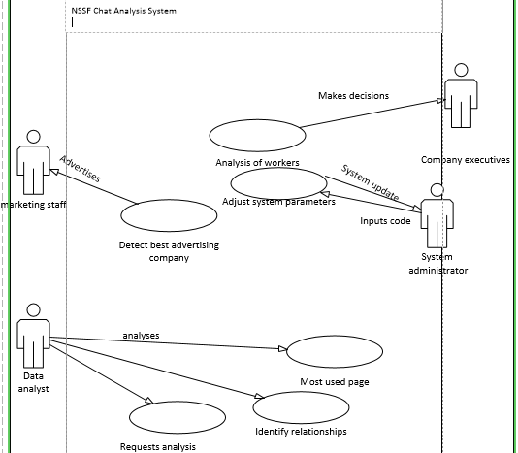

Component Description

Error Correction

Type
This component is a module designed to correct errors in the data stored in the database.
This module is executable.

Purpose
The purpose of the module is to correct spelling errors and errors in phone numbers basing on previously store data and user confirmation.
This component results from errors obtained from company files, for example one phone number can be used by more than one person and same thing for email. Yet the accuracy of this data is important for correct analysis.

Function
The function of this module is to correct errors in the data stored in database.

Subordinates

This component uses mainly the csv file of company stored to identify errors and solve them basing on user.

Dependencies
- This component is called when a user enters a different name to a given phone nunber or different email to a given name.
- When this happens the component asks user to verify name and/or phone number
- After verification the data in the database is edited to the correct value.

Interfaces

All the data in the database is entered into this component to look for errors in the data. If an error is detected the component asks for verification and the data is corrected.

One of the triggers of this component is when a user in the database enters a different name to a given phone number or there is a column in database that is left empty. This component asks for verification of entered details such as name or number. After the verification it corrects the result in the database.

Resources
The component requires data from the csv file. It requires r analysing tools.

References
The component uses information from our SRS document. It also uses the format of the IDA template.

Processing

In case a user enters a different name to a given phone number and there is 80% similarity in name to one originally there --- the system asks for name verification and then correct name stored. Same thing is done in a case of different email and country for given number or name.
For lacking entries compare with available data and predict entry basing on similar name, number or email.

Data
The component uses data from company database given to us in form of a csv file.
Name | type | Number of values | Relationship
Vistor.name | string | 20
Phone | integer | 10 | Primary key
Email | email | 20

Waiting delay correction

Type
This component is a module designed to correct waiting delay problems in the data stored in the database.
This module is executable and it is intended to be incorporated in the company website.

Purpose
The purpose of the module is to reduce the time spent by users of company website in waiting to be assigned an operator.
This component results from large waiting time of given users, for example the maximum wait.time was 591732 and the average was 34460 seconds which shows that most users over waited for their issues to be solved.

Function
The function of this module is to reduce average waiting time.

Subordinates

This component uses a stop clock in the company system. This clock is started when a user accesses a company website.

Dependencies
- This component is called when a user starts using company website.
- When this happens the component assigns user an operator or if no operator available the user wits for the earlier users to be finished.
- After assignment the component is terminated.

Interfaces

All the waiting times in the database is entered into this component to assign operator basing on first come first serve.

The trigger of this component is when a user accesses company database. This component assigns operators after which it terminates.

Resources
The component requires data from the csv file. It requires r analysing tools.

References
The component uses information from our SRS document. It also uses the format of the IDA template.

Processing

In case a user accesses the company website --- a stop clock is started in the website. the times are recorded to this module. The module then assigns operators basing on first come first serve. After this the component terminates.

Data
The component uses data from company database given to us in form of a csv file.
Name | Type | Number of values
Wait.time | integer | 10

Detect best advertising company

Type
This component is a module designed to determine the best company for advertising NSSF activities.
This module is executable.

Purpose
The purpose of the module is to determine best advertising company based on the website user came from.
This component results from different websites users came from where the company advertises, for example www.google.com. This is important for NSSF to know where to advertise.

Function
The function of this module is to get best advertising company.

Subordinates

This component uses mainly the csv file of company stored to identify the companies.

Dependencies
- This component is called whenever NSSF want to find out which companies to user for advertising.
- It simply uses information from the company database.

Interfaces

All the websites user came from in the database is entered into this component to look for the most frequently used. The most used becomes the best advertising company.

The trigger of this component is when an administrator wants to find out the best advertising company.

Resources
The component requires data from the csv file. It requires r analysing tools.

References
The component uses information from our SRS document. It also uses the format of the IDA template.

Processing

In case an admin wants to get the best advertising website, he starts the module.
The module then looks for the most used website to contact NSSF website. This is then displayed as best advertising company.

Data
The component uses data from company database given to us in form of a csv file.
Name | Type | Number of values
Came.from | Website | 20

Analysis of workers performance

Type
This component is a module designed to access operators’ performance.
This module is executable.

Purpose
The purpose of the module is to help NSSF determine which operator to promote or fire.
This component results from chats between operators and users of company website, for example some operators didn’t answer users’ questions.

Function
The function of this module is to examine performance of operators.

Subordinates

This component uses mainly the csv file of company stored to identify chats between users and operators.

Dependencies
- This component is called when an admin wants to analyse how operators deal with clients.
- When this happens the component searches through the chats for information.
- After this it outputs operators performance details.

Interfaces

The data from chat content in the database is entered into this component to look for relationships between operators and responses. And to determine whether operators respond.

The trigger of this component is when an admin clicks it to view operators’ performance. This component analyses chats and gives feedback to admin. After the verification, it corrects the result in the database.

Resources
The component requires data from the csv file. It requires r analysing tools.

References
The component uses information from our SRS document. It also uses the format of the IDA template.

Processing
In case an admin puts on component to view operators’ performance, the component analyses the chat data and shows the relationship between chats and operators.

Data
The component uses data from company database given to us in form of a csv file.
Name | Type | Number of values
Chat.content | string | 1000

request analysis

Type
This component is a module designed to analyse requests made by users of company website and determine the issues the company should deal with.
This module is executable.

Purpose
The purpose of the module is to make sure the requests made by users are attended to.
This component results from unanswered queries from users.

Function
The function of this module is to assign operators to unanswered queries.

Subordinates

This component uses mainly the csv file of company stored to identify unanswered queries of users.

Dependencies
- This component is called when the admin wants to find out which querries were not answered.
- When this happens the component searches through the chats to see the ones needed.

Interfaces

All the data in the database concerning chat content is entered into this component to look for unsolved queries. If an unanswered query is detected the component asks for verification and the data is corrected.

The trigger of this component is when an admin wants to solve unresolved queries.

Resources
The component requires data from the csv file. It requires r analysing tools.

References
The component uses information from our SRS document. It also uses the format of the IDA template.

Processing

In case an admin wants to resolve unanswered queries he calls this module The module analyses chats and returns unresolved queries.

Data
The component uses data from company database given to us in form of a csv file.
Name | Type | Number of values
Chat.content | string | 1000

